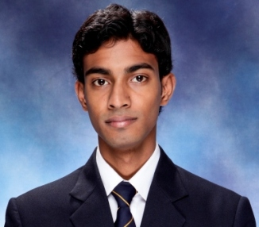
AKASH ADHIKARI
Mobile no. (+91) 9582645850
E-mail: akashadhikari01@gmail.com
Address: H 13/6 Second Floor Malviya Nagar , New Delhi -110017

Career Objective:
To ensure that I enhance my skills and knowledge within the organization and the ability to perform my best at the task I am given.
Career Precise:
Company Name – Infiniti Retail Ltd (TATA CROMA)
Designation – Accounts Executive
Duration – Nov 2013 to May 2014
Reporting To - Area Accountant
Professional Qualification:
- Post Graduate Diploma in Management (PGDM) from Centre for management development, (CMD) Modinagar. Approved by AICTE Ministry of HRD, Government of India and AIU approved (equivalent to M.B.A.), accredited by NBA and an ISO 9001:2008 certified institute.
(Batch 2011-13)
- Bachelor in Commerce (B.COM) from Dayanand Brajendra Swarup (DBS), Kanpur. Affiliated to C.S.J.M University, Kanpur

. Academic Qualification:

Classed Passed | School Name | Year | Board
12th | Wendy Academy High School, Kanpur | 2007 | I S C Delhi
10th | Wendy Academy High School,  Kanpur | 2005 | I C S C Delhi

Skills acquired at college level

COMPUTER PROFICIENCY: MS Office Package i.e. MS -Word, PowerPoint
Internet Fundamentals and Basic Operation
O’Level (internet and web page design)

Summer Training Project
Organization : HDFC LIFE Noida Sec-18
Position : Financial Consultant
Duration : 8 weeks
Project handled
FCCP (Financial Consultant Career Programme)
KRA
- To study the market potential for HDFC LIFE.
- To convince and make aware to the customer about FCCP.
- To recruit the individual who are interested in this programme

Areas of Interest

Finance and Marketing
Industrial Exposure:
- Mother Dairy, Delhi.
- Parle Agro, Rudrapur.
- Jumbo Electronics, Dubai.
- Pepsico, Dubai
Achievement
- Got Runners up position in MANAGEMENT QUIZ at Invertis University , Bareilly
- “PRABHAKAR” in Tabla Playing from Prayag Sangit Samiti . Allahabad
Extra Curricular Activities
- 2011- Qualified for the 2nd round of QUIZ COMPETITION at college level.

- Participated in PRODUCT LAUNCH COMPETITION oraganised by Vidya School of Business.
- Participated in SUPPLY CHAIN MANAGEMENT COMPETITION oraganised by Vidya School of Business.
Personal Vitae:
Father’s Name : Mr. Pradeep Kumar Adhikari
Mother’s Name : Mrs. Kajal Adhikari
Date of Birth : 13th January 1990.
Languages Known : English, Hindi and Bengali

Declaration
I hereby declare that the above-mentioned information is correct up to my knowledge and I bear the responsibility for the correctness of the above-mentioned particulars.

DATE
PLACE: (Akash Adhikari)

